RESTAURANT MANAGEMENT SYSTEM

**Retrospective findings**

**SPRINT 1(1st week)**

**What went well?**

In this sprint we analyzed the project and team coordination, support with respect to time went well. Also, we were able to easily understand the project clearly.

**What could have been better?**

In our project, we were not able to fulfill the type of Entity as per the product owner required. And we were lacking some technical concepts.

**Things to try?**

Distribution of task with all the team members with respect to their capabilities.

**Issues to Escalate?**

CORS error occurred due to API and MVC connectivity (i.e., API limits time).

**Sprint 1 backlog**

**SPRINT BURNDOWN CHART**

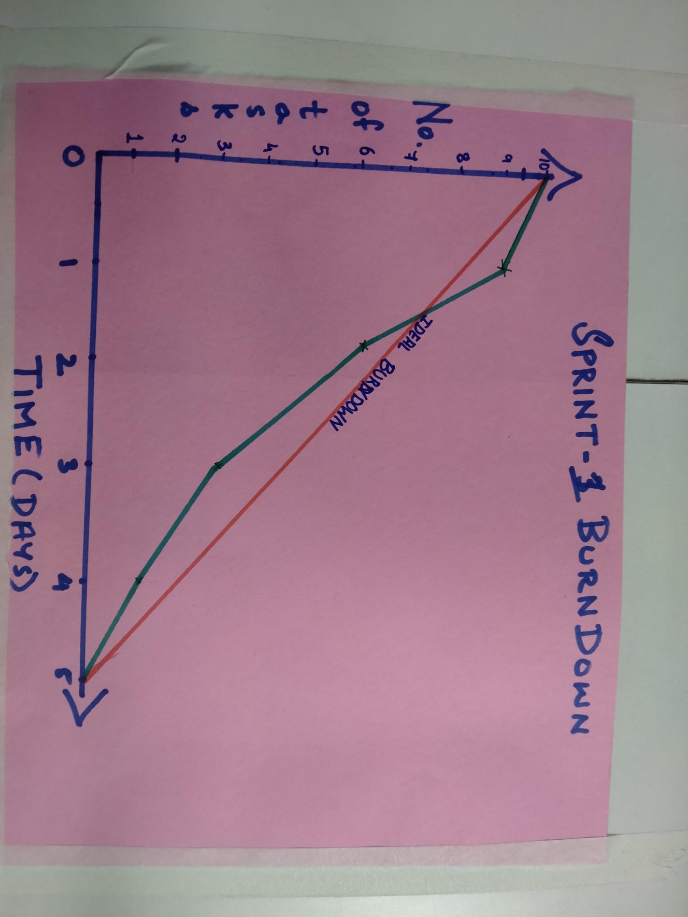

**SPRINT 2 (2ND WEEK)**

**What went well?**

The functionalities of adding the items to CART worked well. All the major assigned work to the team was completed successfully, with team coordination.

**What could have been better?**

We have done UI but not Responsive UI with respect to WebView.

**Things to try?**

Exceptional handling, Back Button on every page, Customer Name and Email in Bill.

**Issues to Escalate?**

Need to try out a feedback page to display after paying the bill and implement the feature that it’s completely optional.

**Sprint 2 backlog**

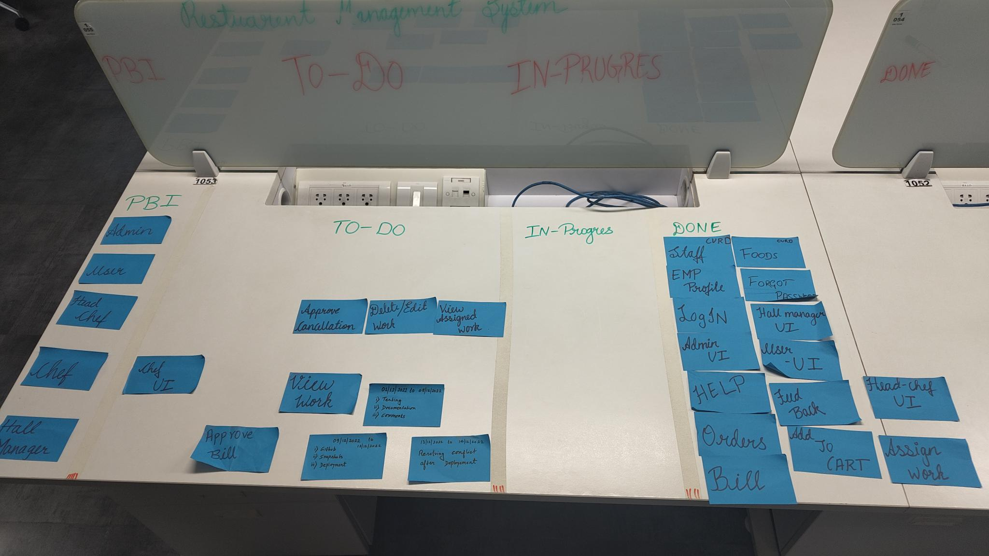

**SPRINT BURNDOWN CHART**

**SPRINT 3(3rd week)**

**What went well?**

Feedback and Exit button worked successfully.

**What could have been better?**

The alignment of UI could have been better

**Things to try?**

Testing and Deployment of the project.

**Issues to Escalate?**

Better understanding of Unit testing Skills

**Sprint 3 backlog**

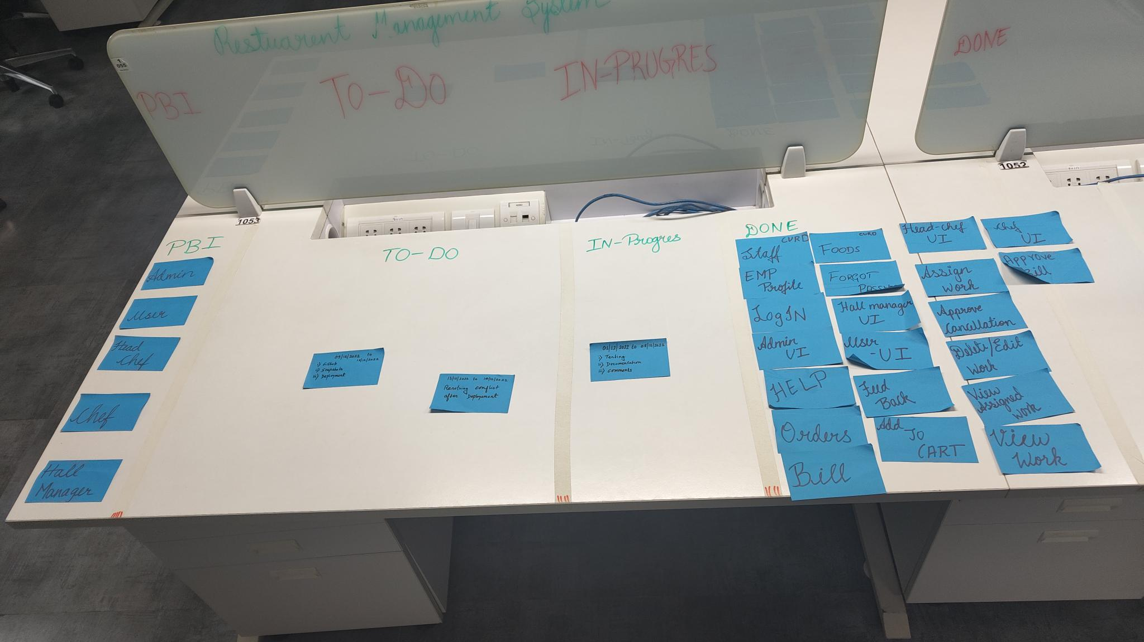

**SPRINT BURNDOWN CHART**

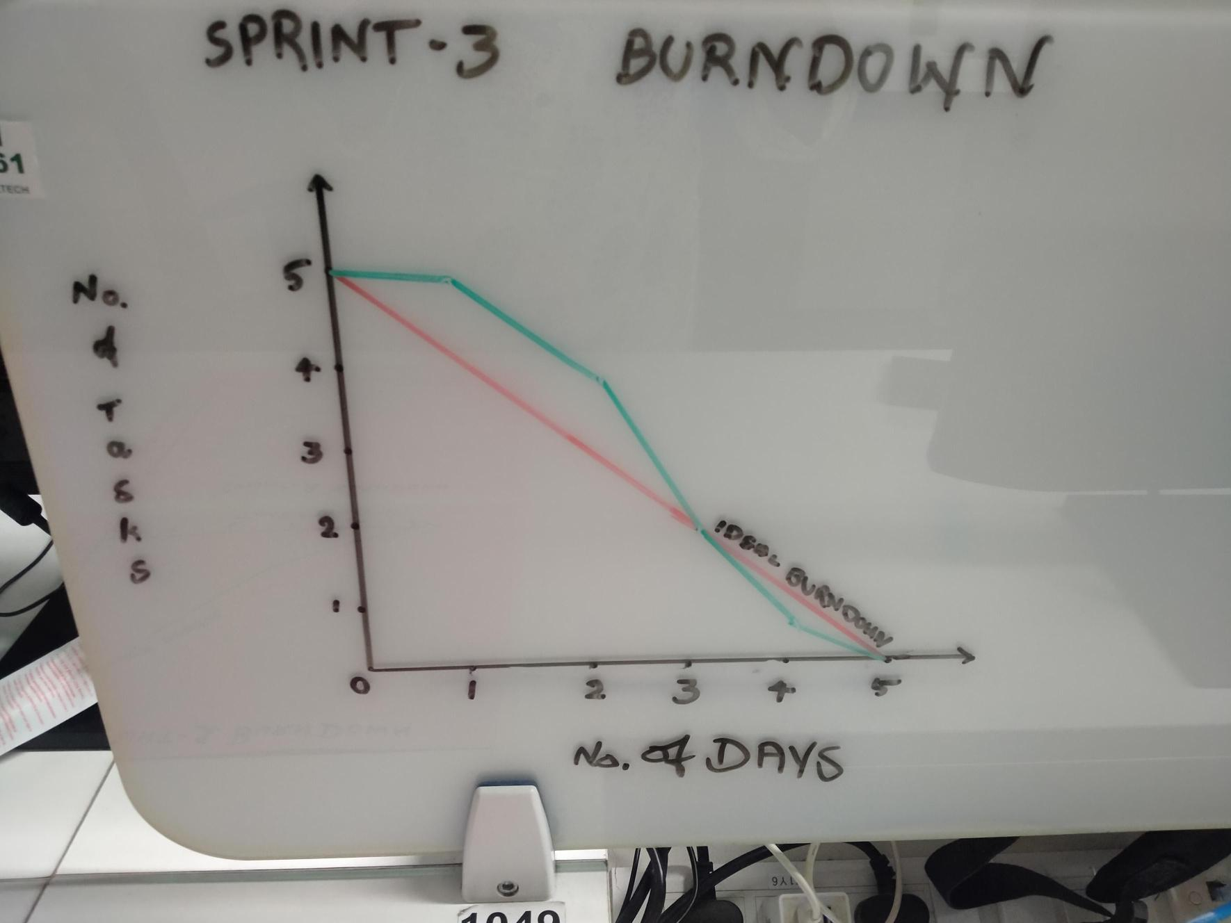

**SPRINT 4(4Th week)**

**What went well?**

All the functionalities is working as per the client needs .

**What could have been better?**

The design of UI could have been responsive with respect to Mobile and Tablet devices.

**Things to try?**

Logger framework

**Issues to Escalate?**

No issues

**Sprint 4 backlog**

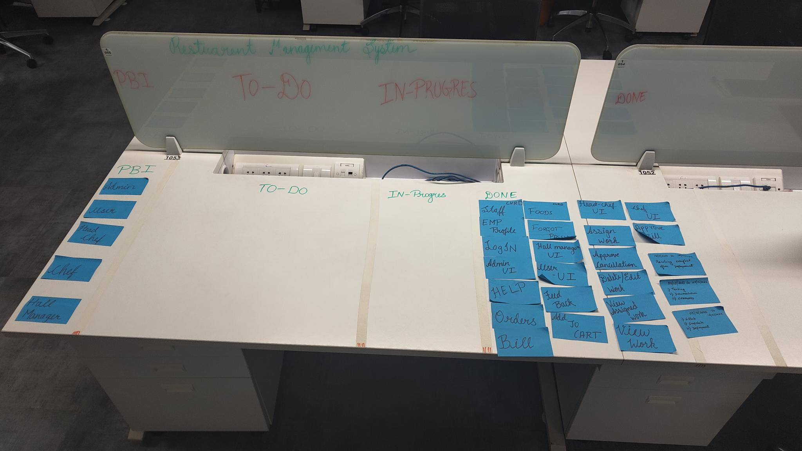

**SPRINT BURNDOWN CHART**

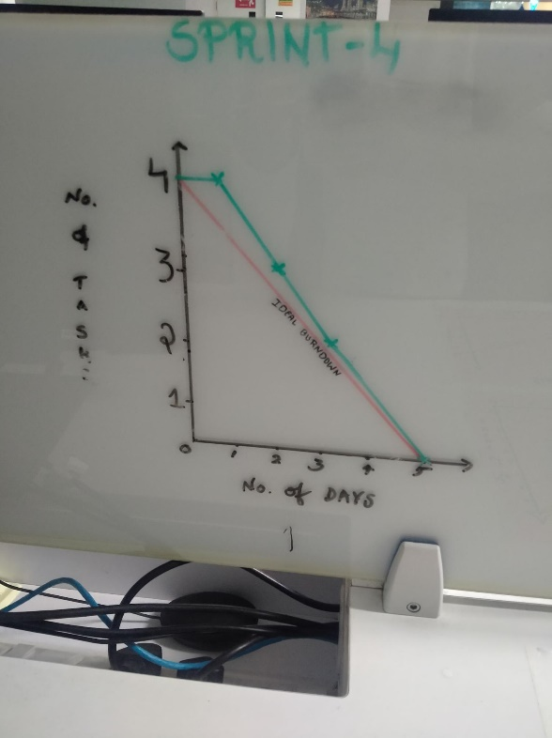

[kiranmh066/Restaurant_All (github.com)](https://github.com/kiranmh066/Restaurant_All)

**PLANNING AND DESIGN**

